Add More Content Sections on Home Page

Set the Hero Section Layout & Content to the Left Allignment


Add Business Stats Bar (below Hero Section):

Add all the Service DIVs/Blocks:
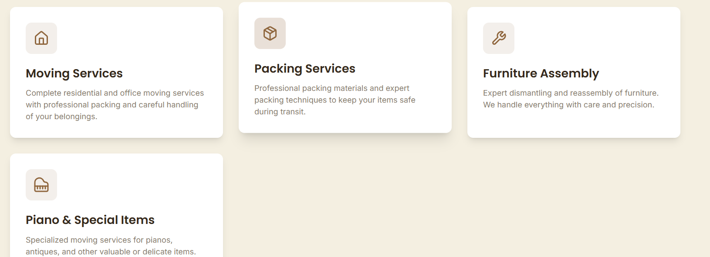

Replace the Content (not the Design) of Why Choose section with this:
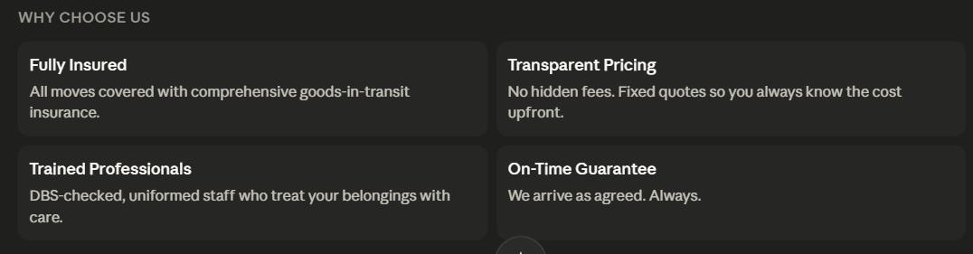

Add “How it Works/ Our Process of Services”Heading
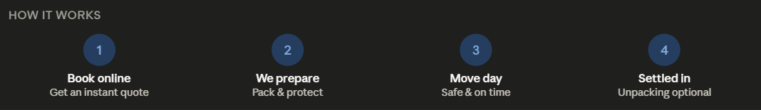

Also Add a section of Areas we Cover


Add an Image Carousel Section that Displays images of our work in horizontal single line Image Carousel.


Add an FAQs Section
